**Final Report**

Tijmen Van Der Beek

5/8/2021

UB# 50240699

**Objective**

The objective of this project is to create 3 different adders and compare their size, power consumption, and delay. The final design will use a multiplexer to pick what adder you want to use.

**Project Truth Table**

The Select bit chooses the adder when Select is 00 it’s the ripple carrier adder, 01 is the parallel prefix adder, 10 is the conditional sum adder, and 11 disables the output.

|  |  |  |  |
| --- | --- | --- | --- |
| A | B | Select | Output |
| 1111 | 1111 | 00 | 11110 |
| 0111 | 0111 | 00 | 01110 |
| 1011 | 1011 | 00 | 10110 |
| 0011 | 0011 | 00 | 00110 |
| 1101 | 1101 | 01 | 11010 |
| 0101 | 0101 | 01 | 01010 |
| 1001 | 1001 | 01 | 10010 |
| 0001 | 0001 | 01 | 00010 |
| 1110 | 1110 | 10 | 11100 |
| 0110 | 0110 | 10 | 01100 |
| 1010 | 1010 | 10 | 10100 |
| 0010 | 0010 | 10 | 00100 |
| 1100 | 1100 | 11 | 00000 |
| 0100 | 0100 | 11 | 00000 |
| 1000 | 1000 | 11 | 00000 |
| 0000 | 0000 | 11 | 00000 |

**Multiplexer**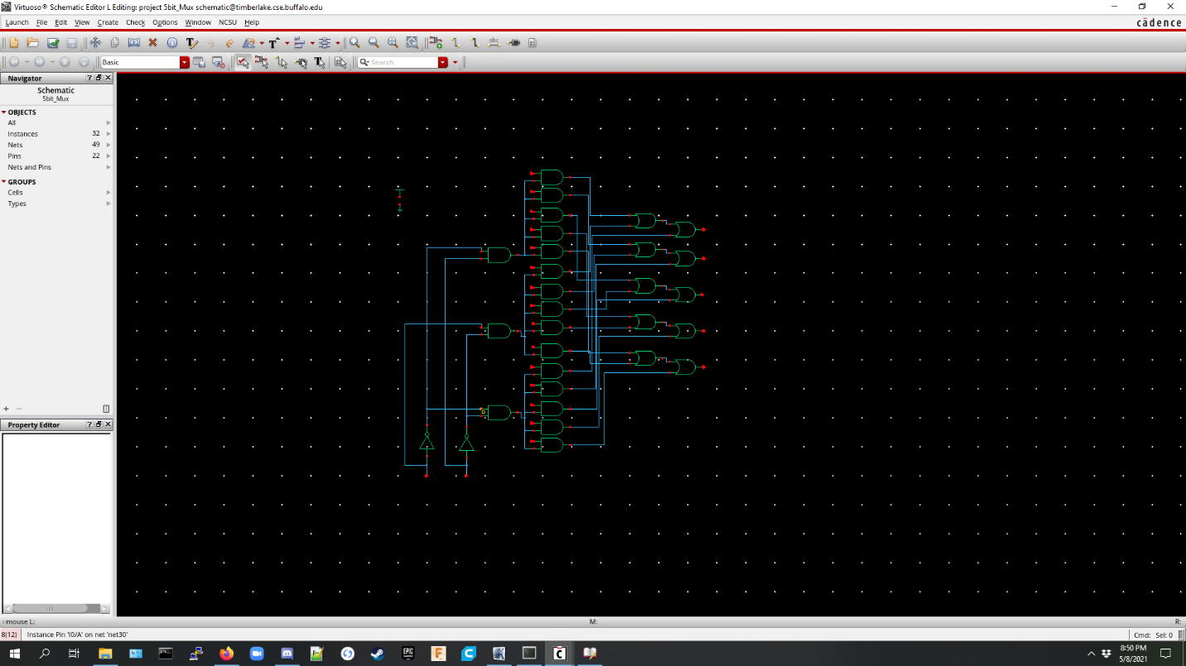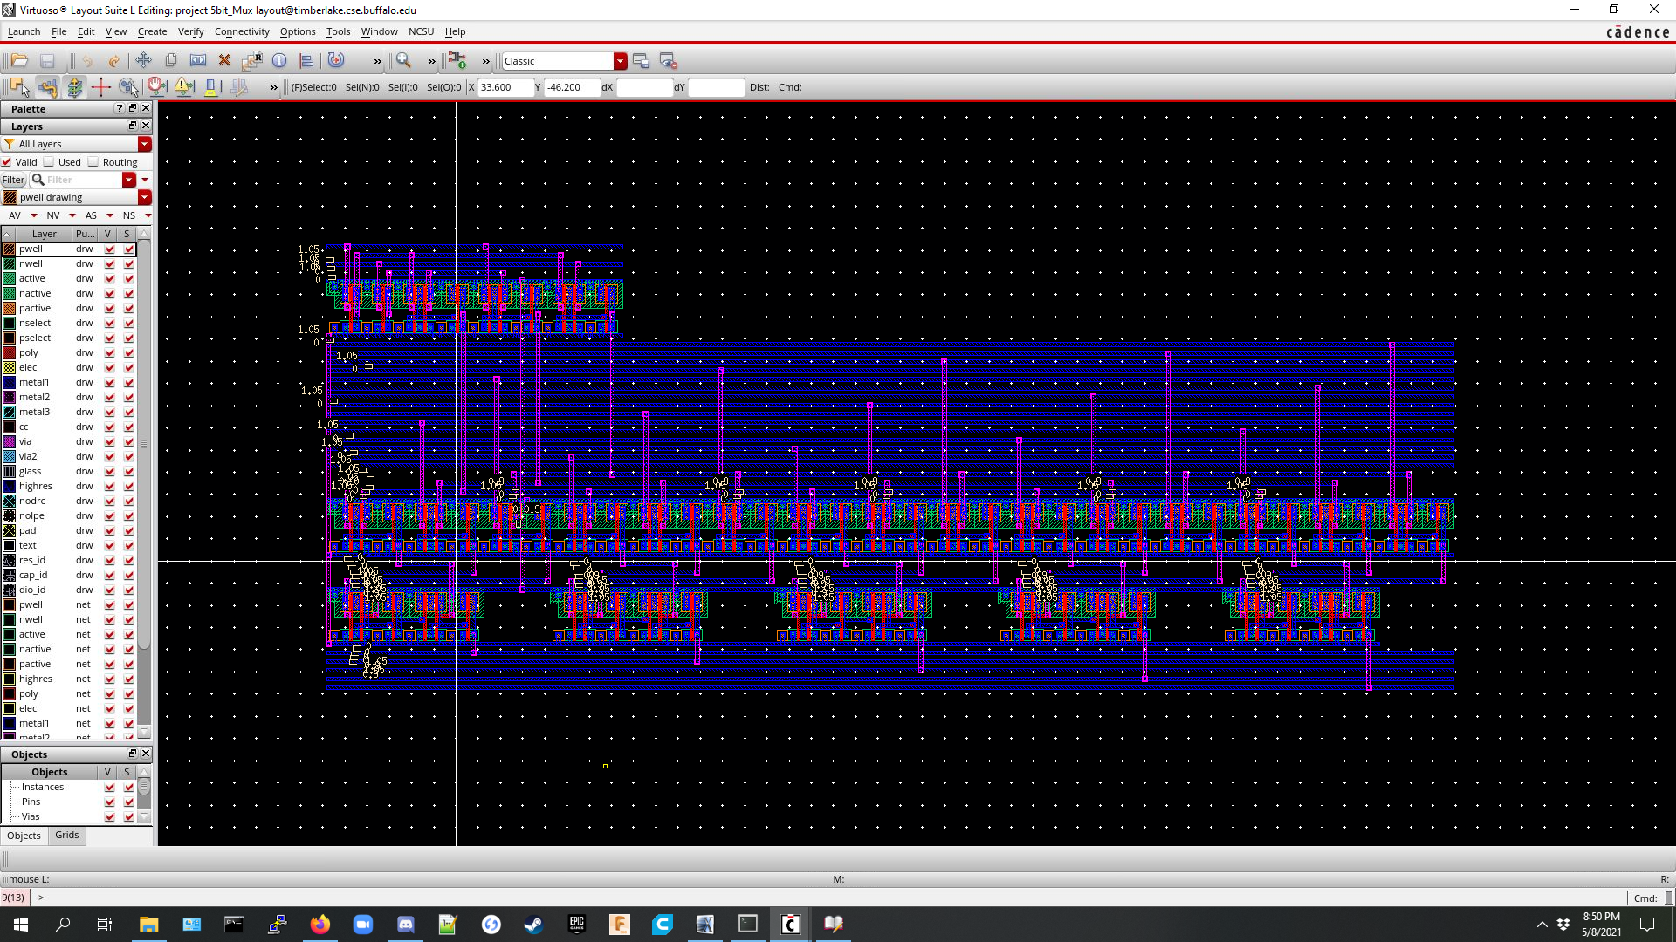

**Ripple Carrier Adder**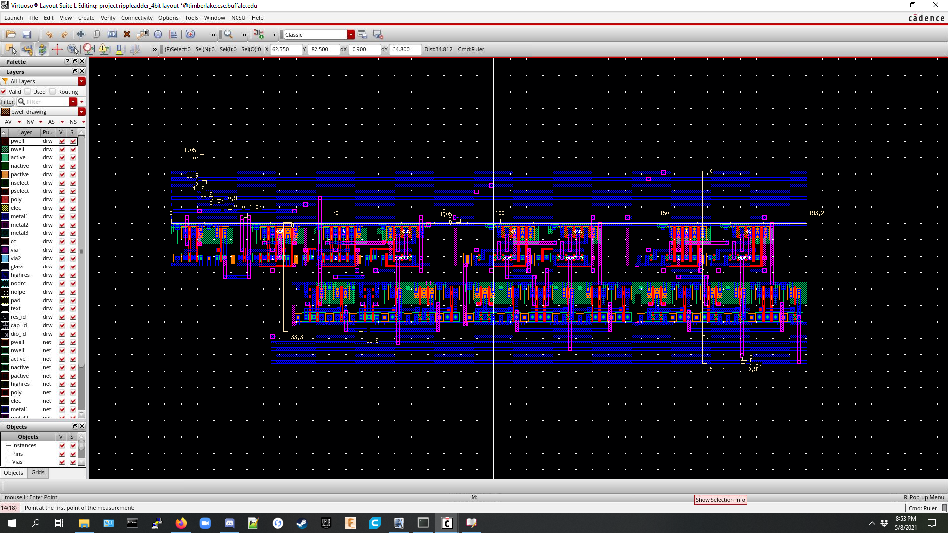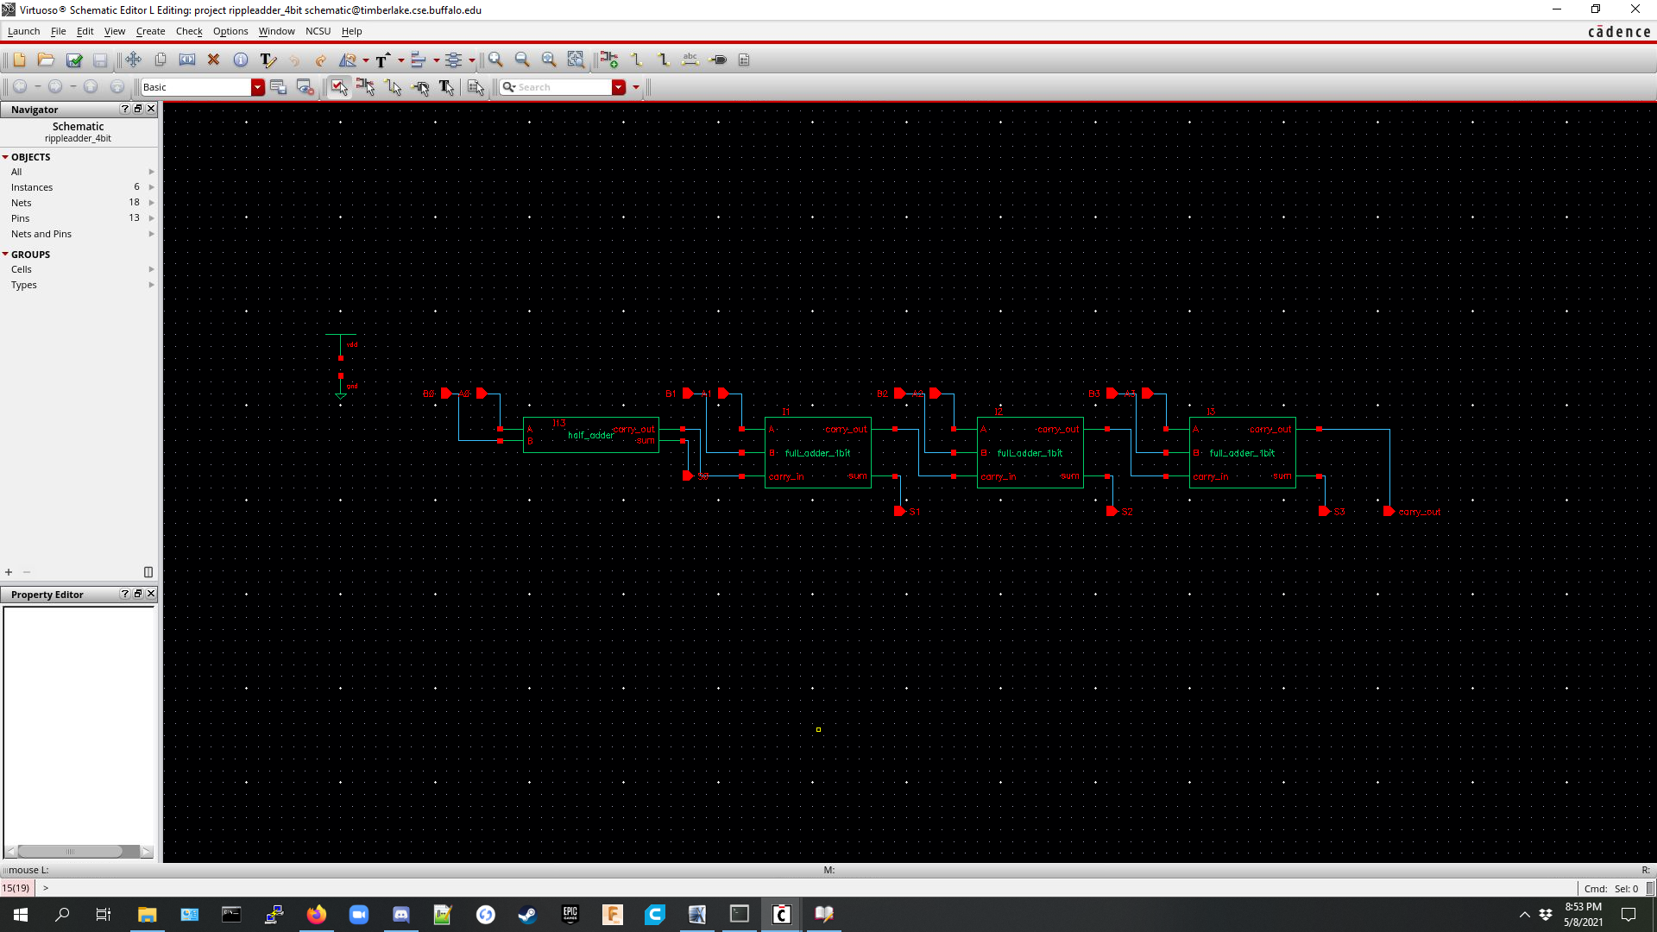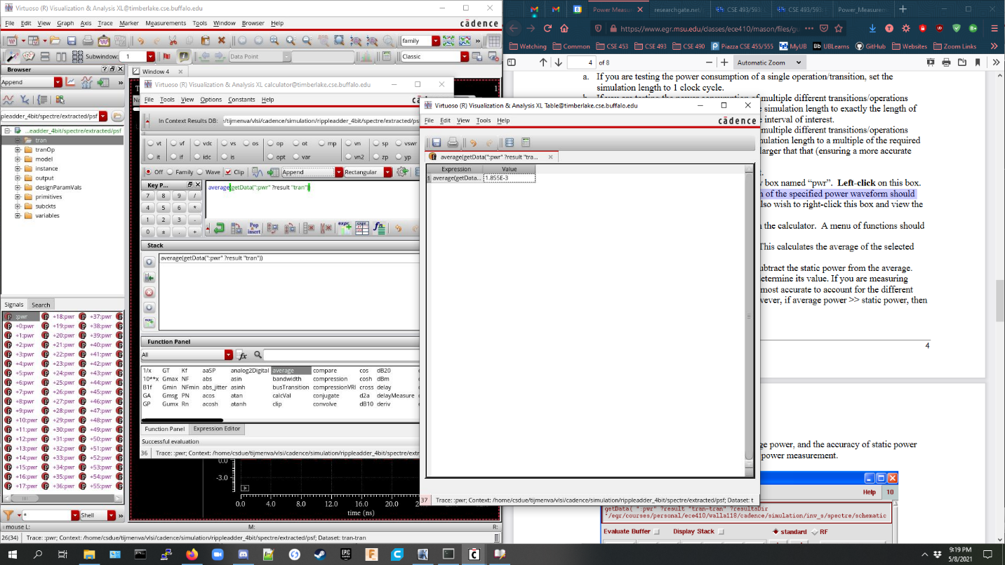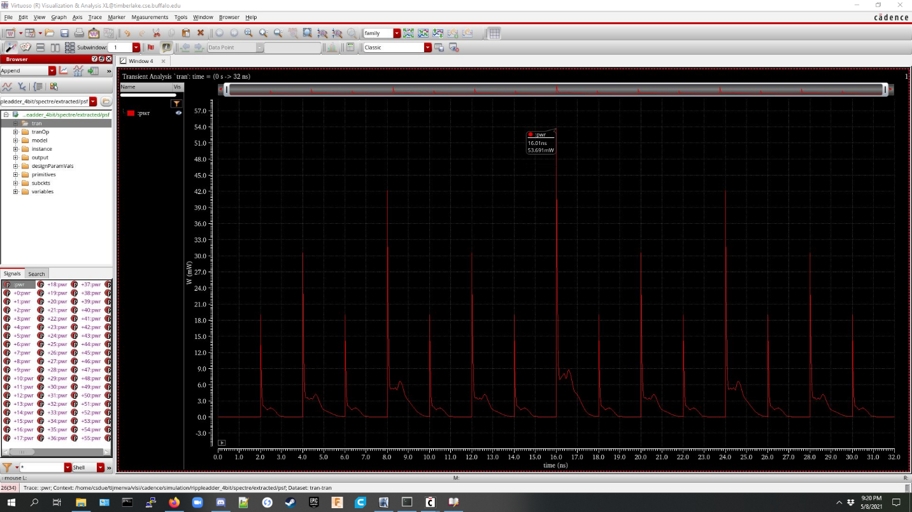

Final Size: 193.2um * 58.65um

Average Power Consumption: 18.55 mW

Propagation Delay: .7085ns

**Conditional Sum Adder**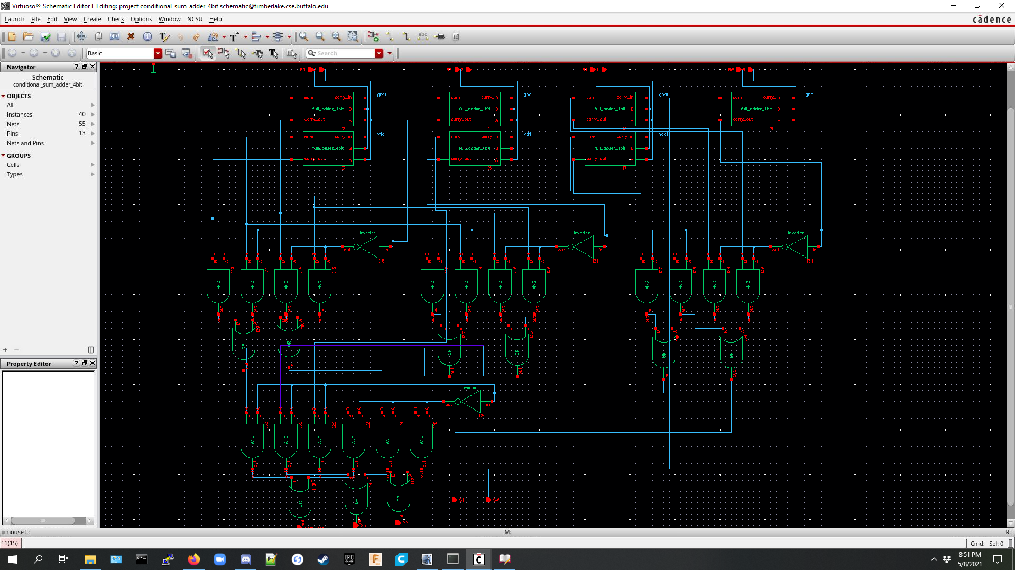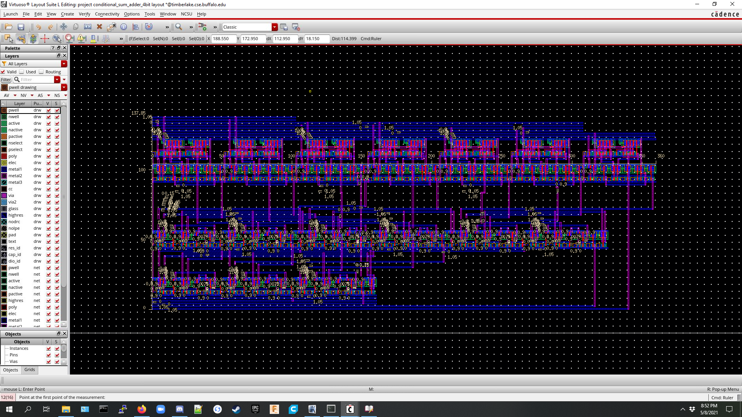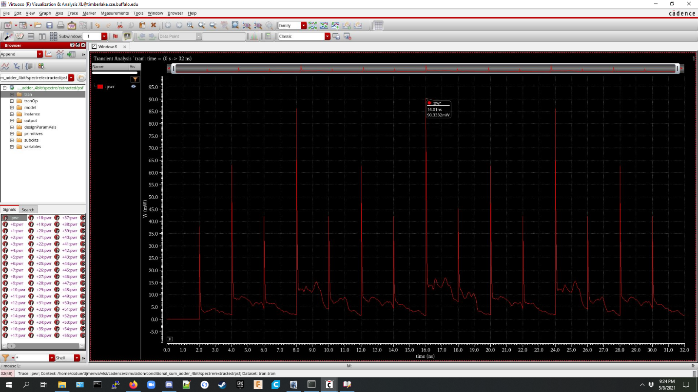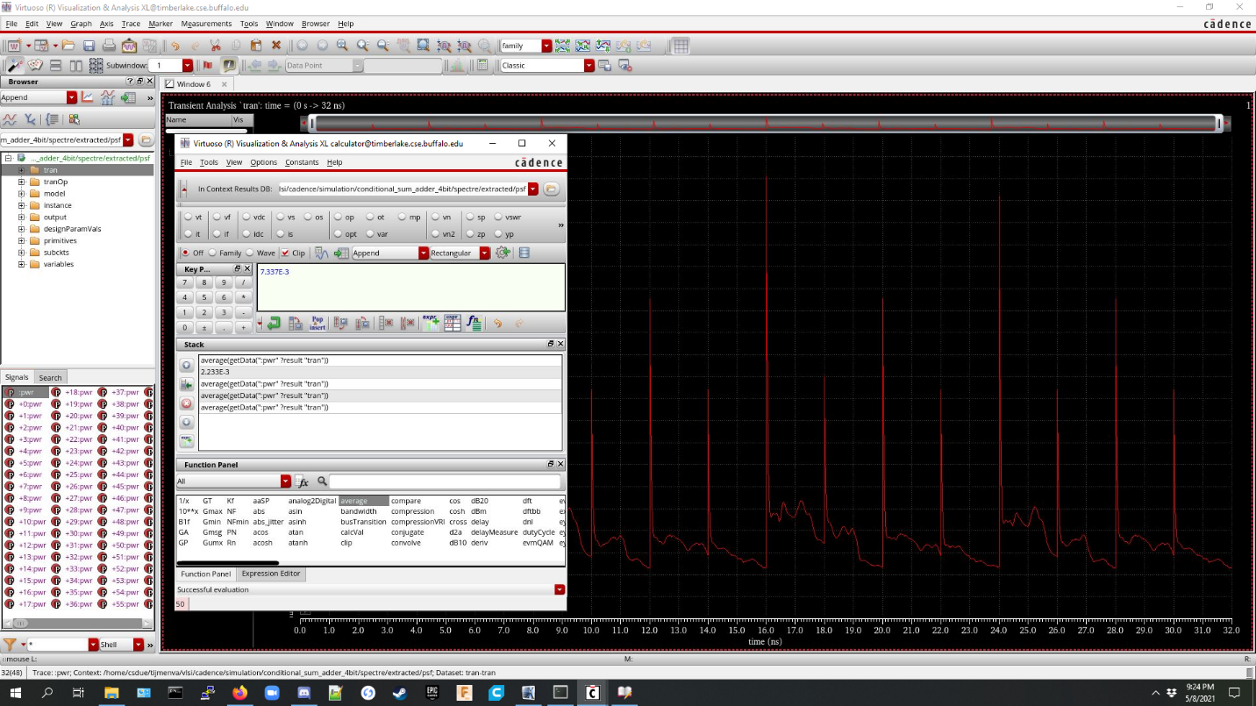

Final Size: 360um * 137.85um

Average Power Consumption: 73.37 mW

Propagation Delay: .8705 ns

**Parallel Prefix Adder**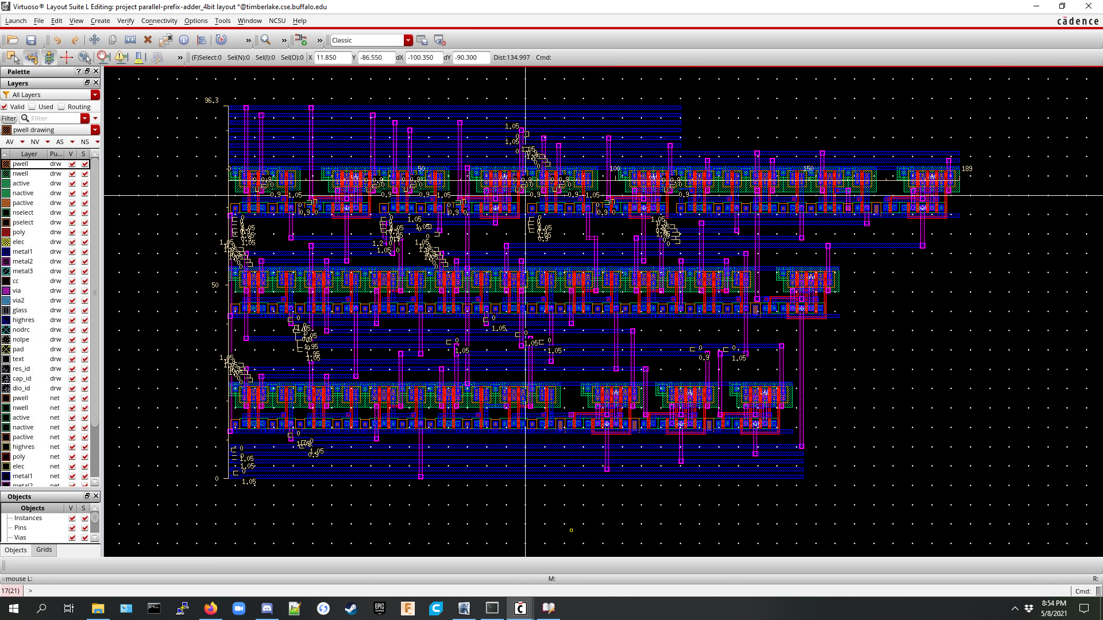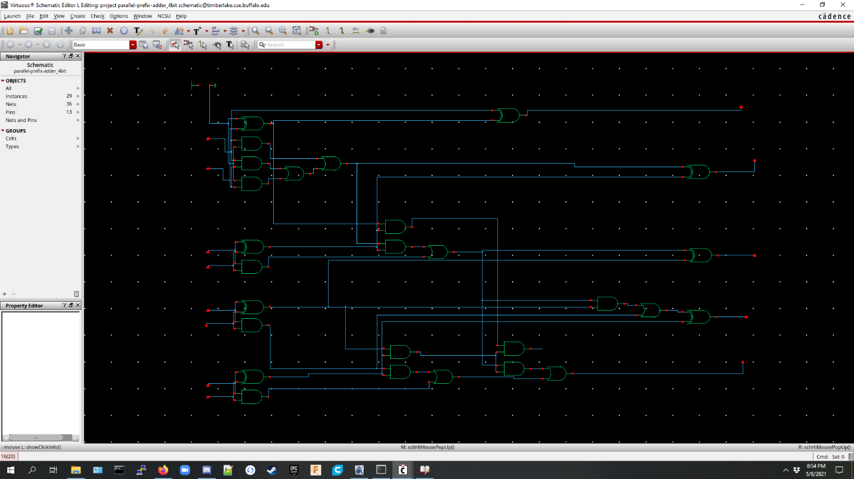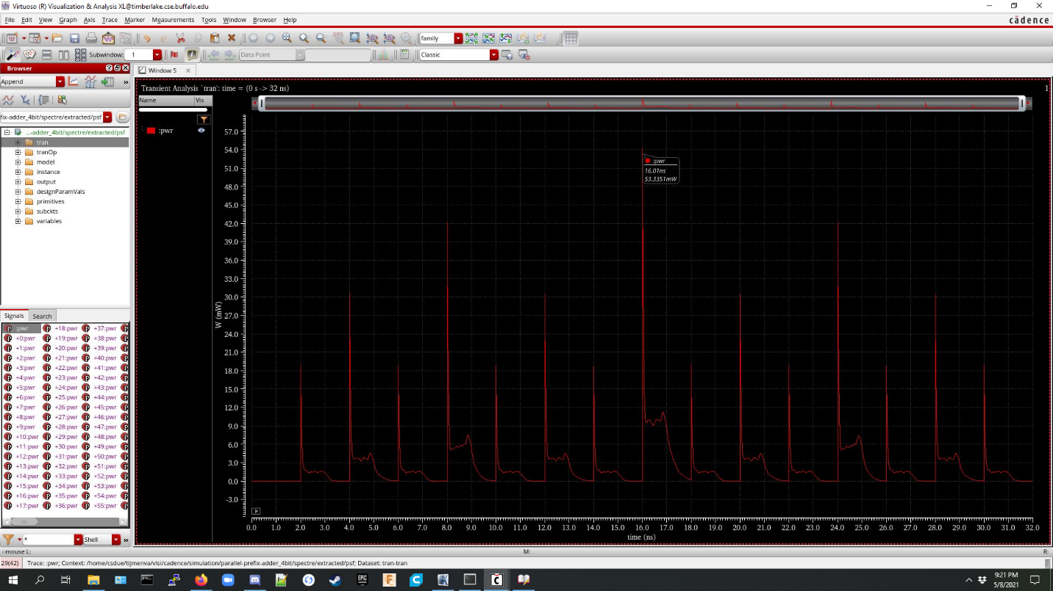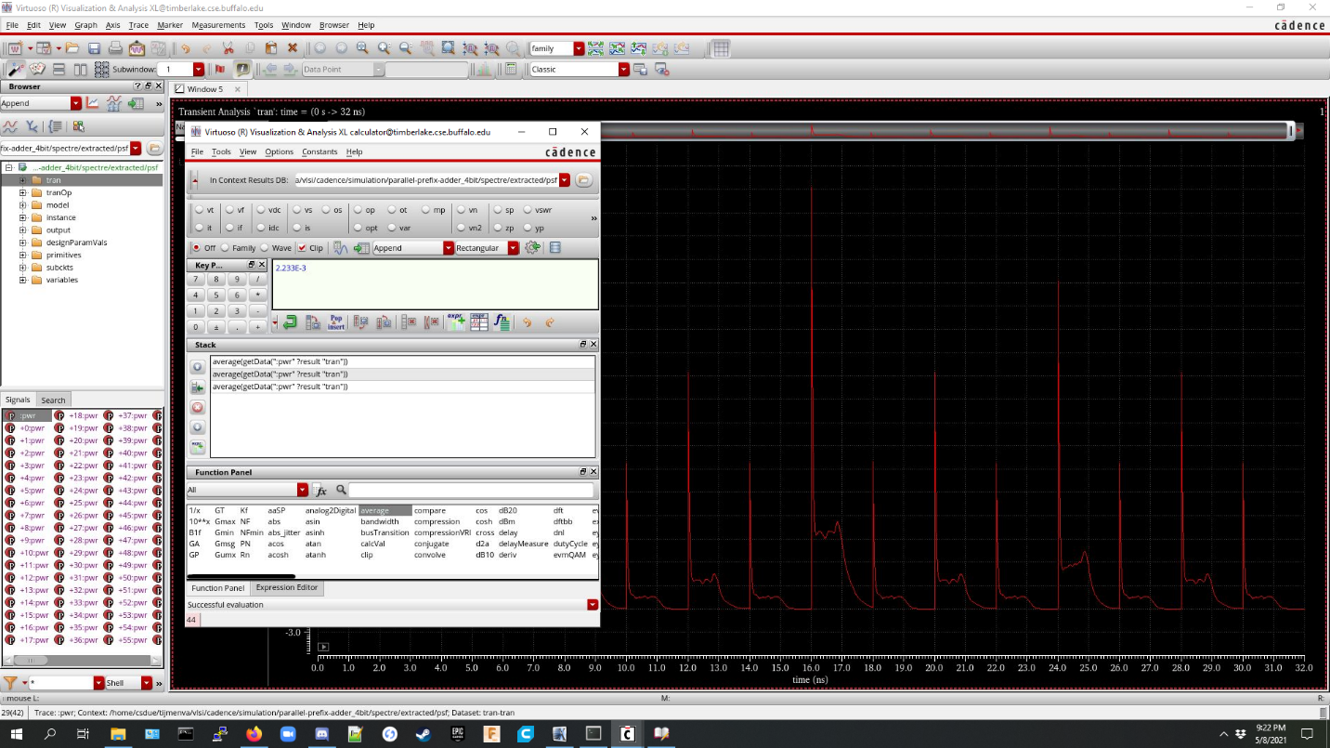

Final Size: 189um * 96.3um

Average Power Consumption: 22.33 mW

Propagation Delay: 1.024 ns

**Final Design**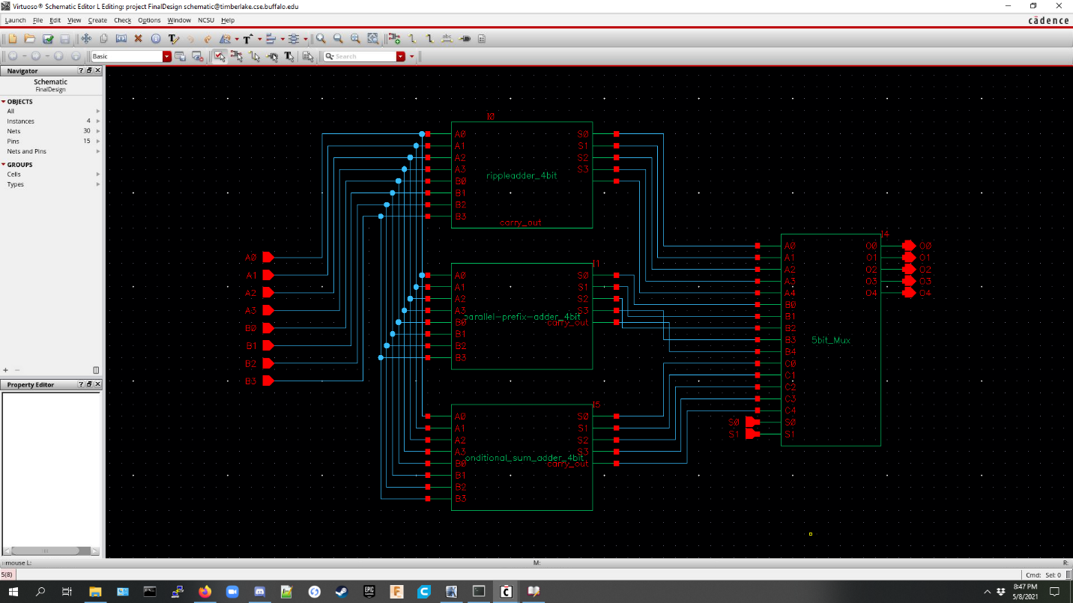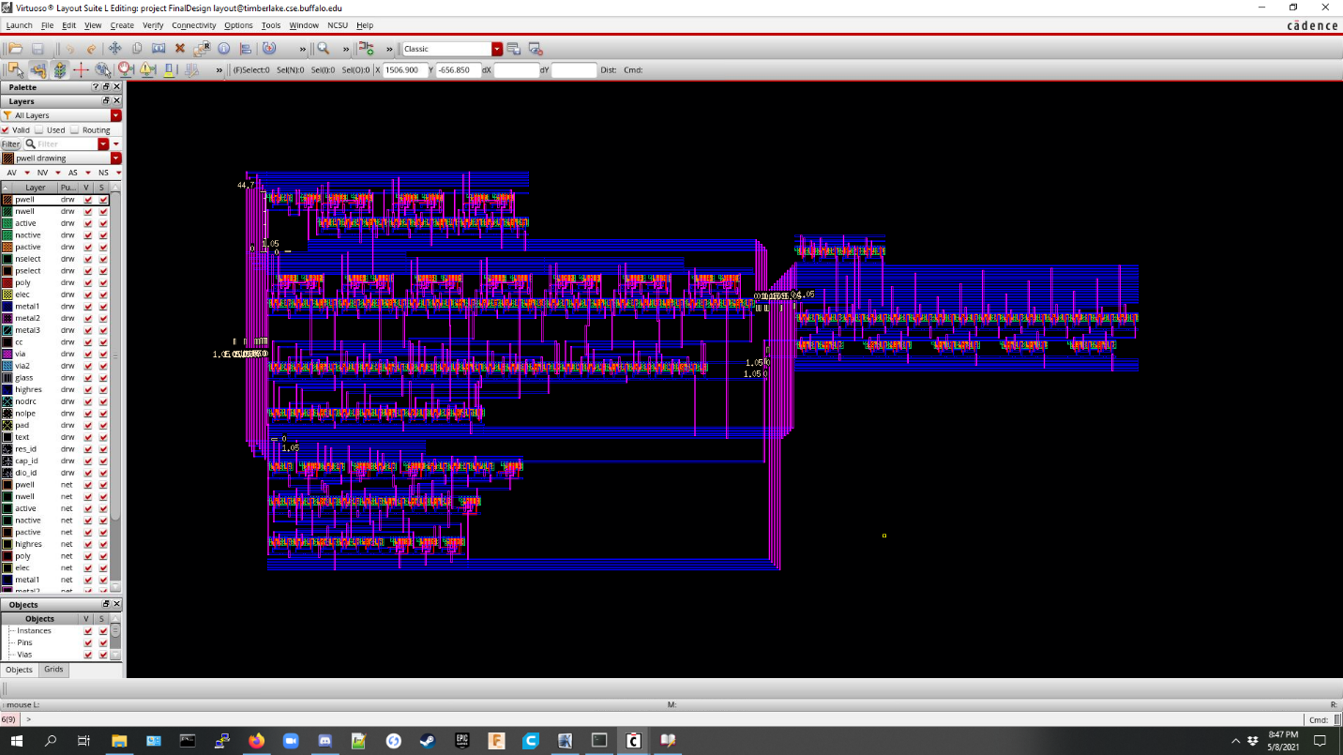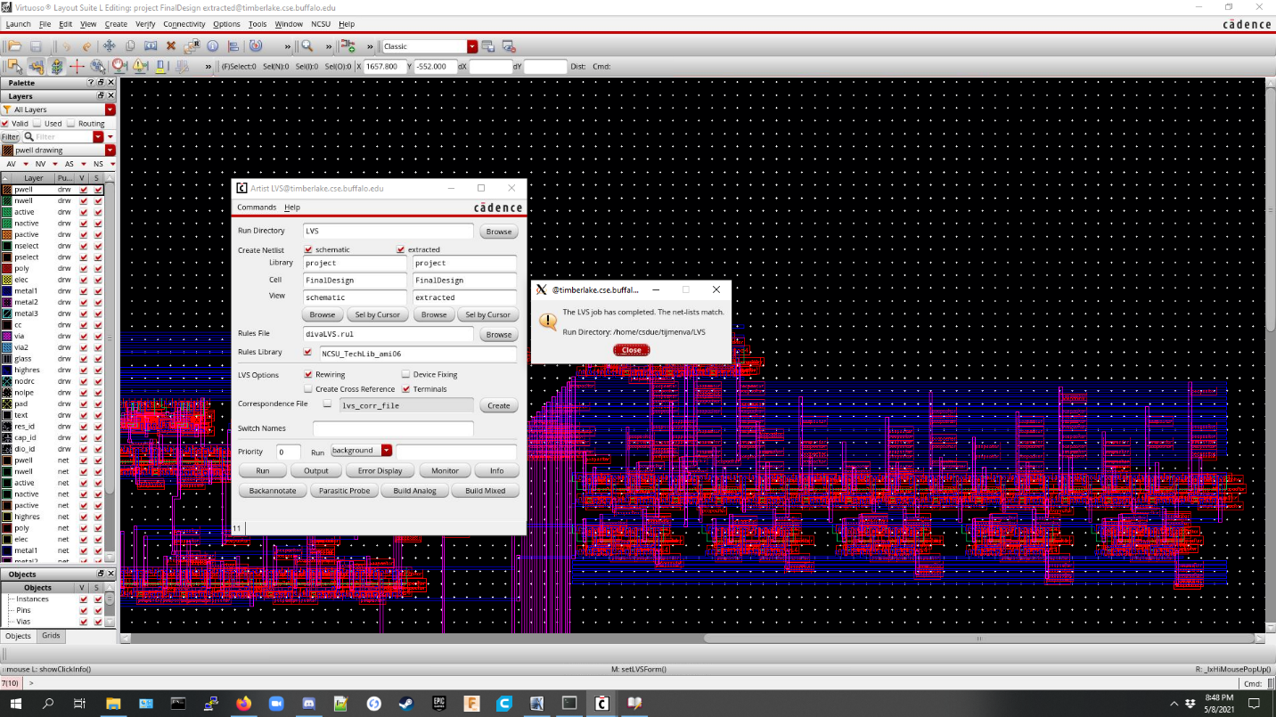

**Final Pad frame**